

Department of Computer Science & Engineering

Project Completion Report

CSE 309: Web Applications and Internet

Group 27

| Name | ID |
| --- | --- |
| Rayhan Pervej | 2022078 |
| Ashikur Rahman Piyal | 2022613 |
| Maimona Minha | 2022140 |
| Anik Barua | 2020059 |

**Software Development Completion Report for Quick Blood Website**

**Abstract**

This report summarizes the work done, the results achieved, the challenges faced, and the lessons learned during the software development project of a quick blood website. This project introduces a Blood Donation Website designed to enhance the efficiency and coordination of blood donation processes. Catering to three main users—donors, recipients, and blood banks—the platform ensures a personalized experience with individualized dashboards. With an emphasis on user-centric design, the website provides individualized dashboards accessible through secure login credentials. This approach ensures a seamless and secure experience for each user category. The website has the following main features: a home page and a navigation menu from where you can go to the login page, about page and contact us page. The website was developed using HTML, CSS, JavaScript, Bootstrap, PHP, and MySQL. The platform will utilize user-friendly interfaces, interactive features, and data-driven insights to facilitate donor registration, appointment scheduling, location-based search of blood drives, and post-donation follow-up. The proposed methodology adopts a user-centric approach, integrating feedback mechanisms and gamification strategies to enhance user engagement and encourage repeat donations.

**Introduction**

Blood donation plays a crucial role in modern healthcare, saving countless lives every year. However, the current system often faces challenges like inefficient communication, limited access to information, and cumbersome processes. This web-based blood donation application addresses these issues by creating a centralized platform for all stakeholders involved. This project introduces a web-based solution designed to streamline the blood donation process. The website provides a user-friendly interface for donors, recipients, and blood banks, offering personalized dashboards to cater to their specific needs. Key features of this website include:

* **User-specific dashboards:** Donors, recipients, and blood banks can access their own tailored dashboards, streamlining their experience.
* **Donation management:** Donors can schedule appointments, track their donation history, and view blood requests.
* **Blood request system:** Recipients can easily request specific blood types, find nearby blood banks, and check blood availability.
* **Blood bank management:** Blood banks can manage their blood stock, request specific blood types, and respond to emergency requests.

**Methodology**

The methodology encompasses a structured approach involving planning, design, implementation, testing, and evaluation to ensure the seamless development and deployment of the quick blood Website.

* **Planning:** Through a thorough user needs analysis, identified key requirements and translated them into a set of well-defined system functionalities and features. A user-centered design approach fostered the development of an intuitive and engaging user interface and user experience. A robust system architecture and database schema were then crafted to provide a solid foundation for development. Finally, the team meticulously chose appropriate development tools and technologies to ensure efficient and successful implementation.

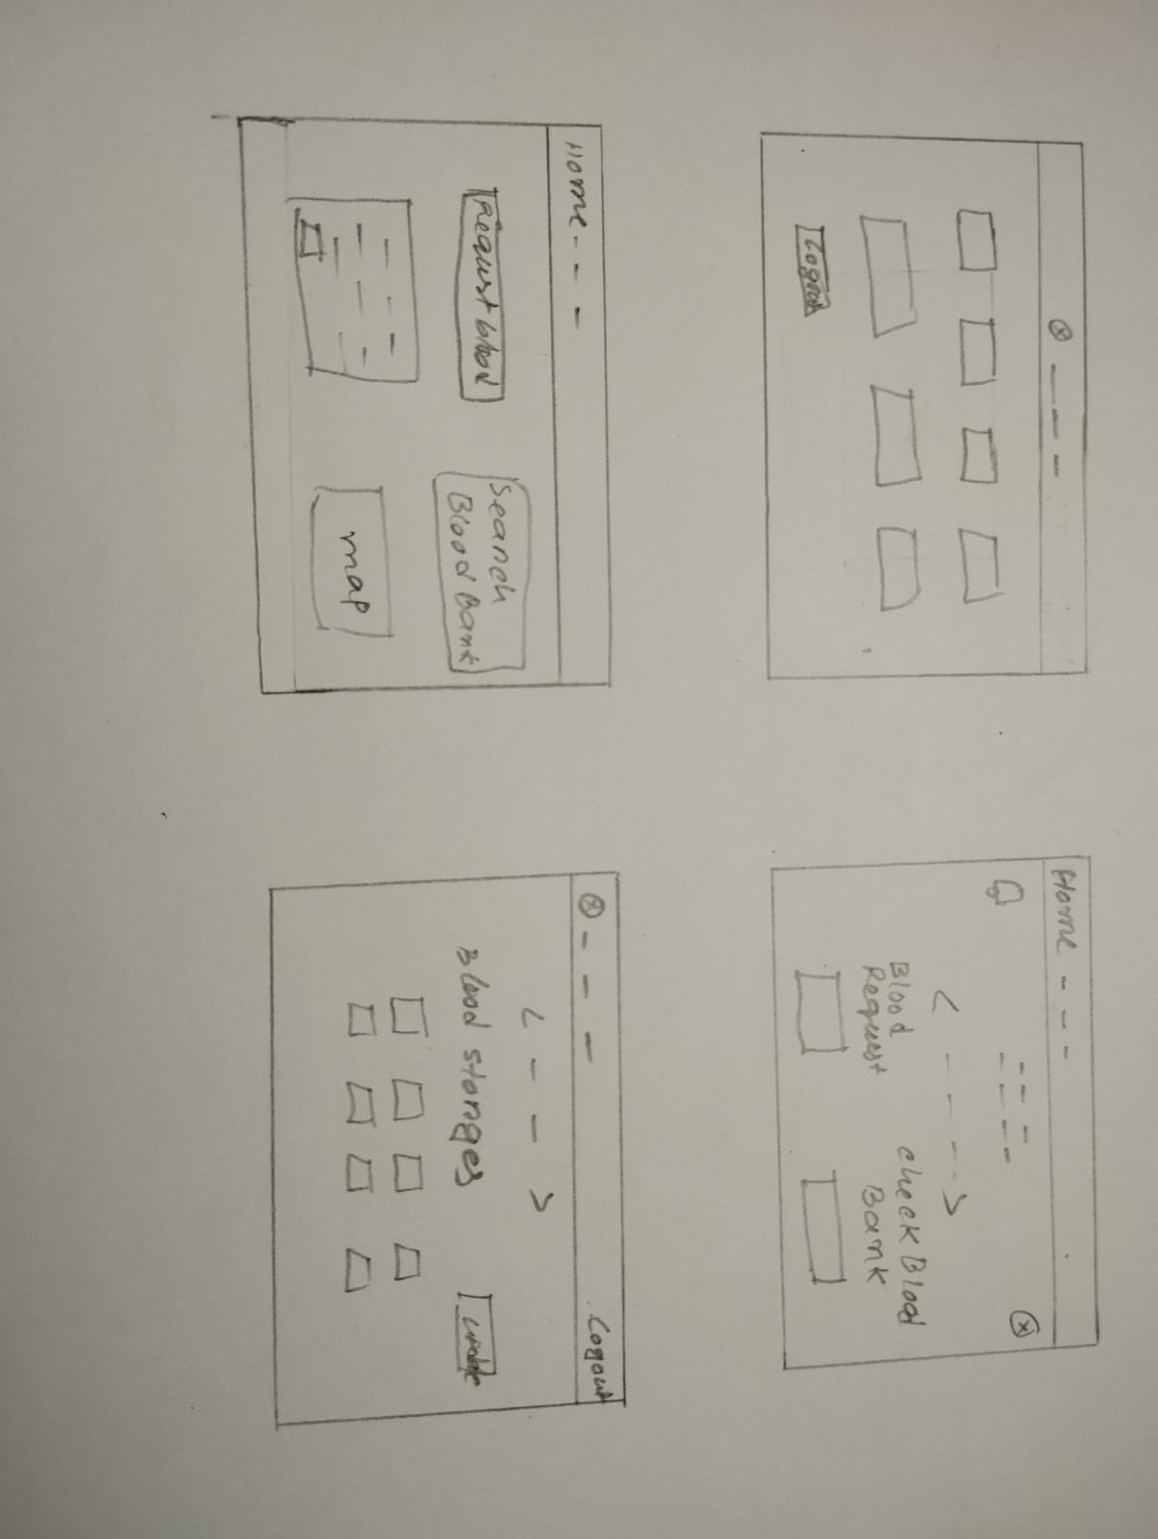

*Figure 1: Hand Drawn framework*

* **Design:** The software developer meticulously crafted the blueprint for the quick blood website, considering the unique roles of three key user types: donors, recipients, and blood banks. The developer employed wireframes, mockups, and prototypes to meticulously design the layout, structure, and visual aesthetics of the website, ensuring a seamless and user-friendly experience for all stakeholders. Simultaneously, the software developer delved into the intricacies of data management, designing a robust database schema and data model. Utilizing entity-relationship diagrams and applying normalization techniques, they ensured efficient organization and retrieval of information tailored to the specific needs of donors, recipients, and blood banks. With a focus on functionality and logic, the software developer employed flowcharts, pseudocode, and algorithms to define the dynamic processes inherent to the blood donation website. This involved outlining the intricate workflows for donor registrations, blood requests, and inventory management within blood banks. Recognizing the importance of stakeholder input, the software developer actively engaged with donors, recipients, and blood banks. Through presentations and demonstrations, the developer sought approval and valuable feedback on the design, ensuring that the website aligns seamlessly with the expectations and requirements of each user type. This collaborative approach aimed to create a blood donation platform that not only meets industry standards but also addresses the unique needs of donors, recipients, and blood banks, ultimately fostering a supportive and efficient ecosystem for blood donation.
* **Implementation:** The software development team brings the meticulously designed blood donation website to life. Employing a robust stack of technologies, the implementation is executed using HTML, CSS, JavaScript, Bootstrap, jQuery, PHP, and MySQL to ensure a dynamic and responsive web experience.
  + **HTML, CSS, JavaScript:** These fundamental technologies form the backbone of the website's structure, style, and interactivity, providing a seamless and engaging user experience.
  + **Bootstrap:** Utilized for responsive design, ensuring the website is accessible and user-friendly across various devices and screen sizes.
  + **PHP:** Employed for server-side scripting to process forms, manage user authentication, and interact with the database.
  + **MySQL:** The relational database management system is utilized to store and retrieve user data, blood inventory details, and other critical information.

The software developer adheres rigorously to industry-recognized coding standards, conventions, and guidelines. To manage the evolving codebase, version control tools such as Git are employed. This facilitates collaboration among team members and provides a systematic approach to tracking changes, resolving issues, and maintaining code integrity. Comprehensive documentation, including inline comments and README files, is maintained to assist developers in understanding the code and its functionalities.

* **Testing:** During the testing phase of the blood donation website development, a comprehensive approach was adopted to ensure the robustness and reliability of the platform. The software developer systematically assessed the website for functionality, usability, performance, security, and compatibility through a series of testing methods, tools, and techniques. Unit testing was employed to scrutinize individual components, while integration testing validated seamless interactions among different modules. System testing was conducted to evaluate the website as a cohesive entity, and user acceptance testing involved stakeholders actively engaging with the platform to confirm alignment with expectations. In addition to verifying functionality and logic, usability testing was performed to assess the user interface's intuitiveness and navigation. Load testing gauged the website's performance under varying traffic conditions, while stress testing pushed the system to its limits to identify potential weaknesses. Security testing was a paramount concern, aiming to uncover and mitigate vulnerabilities that could compromise user data and the overall system integrity. Compatibility was a focal point, with cross-browser testing ensuring consistent functionality across diverse browsers such as Chrome, Firefox, and Safari. Cross-device testing confirmed the website's responsiveness and compatibility with a range of devices, including desktops, tablets, and mobile phones.
* **Evaluation:** The software developer conducted a thorough assessment based on feedback from both users and stakeholders, utilizing a diverse set of evaluation methods, tools, and techniques. User-centric approaches included user feedback surveys, reviews, and analytics, allowing the software developer to gather comprehensive insights into the experiences and preferences of individuals engaging with the quick blood platform. Concurrently, stakeholder perspectives were obtained through surveys, reviews, and analytics to understand their expectations and requirements. User feedback surveys were distributed to collect structured responses. Reviews and analytics were employed to evaluate the usability, performance, and engagement metrics of the quick blood website, offering a holistic view of user interactions. Similarly, stakeholder feedback surveys, reviews, and analytics were conducted to capture the viewpoints of those invested in the success of the blood donation platform. This comprehensive approach ensured a well-rounded understanding of both user and stakeholder expectations, enabling the software developer to make informed decisions for improvements and refinements. Transparent communication was maintained throughout the evaluation process, with the software developer actively presenting and discussing the results and outcomes with stakeholders. This collaborative approach facilitated a two-way exchange, allowing stakeholders to provide approval and valuable feedback on the evaluation. The iterative nature of this communication loop ensures that the blood donation website aligns seamlessly with user needs and stakeholder expectations, ultimately leading to a more effective and user-friendly platform for blood donation.

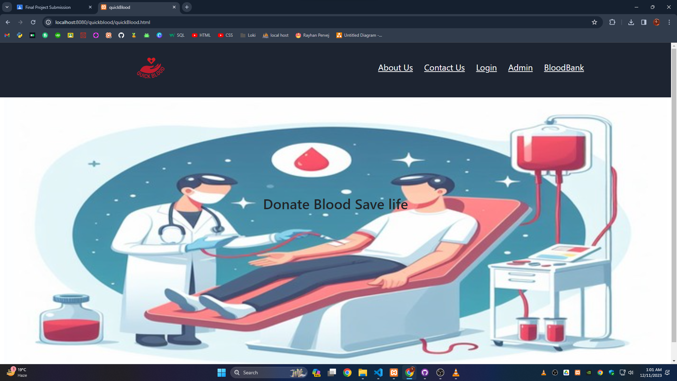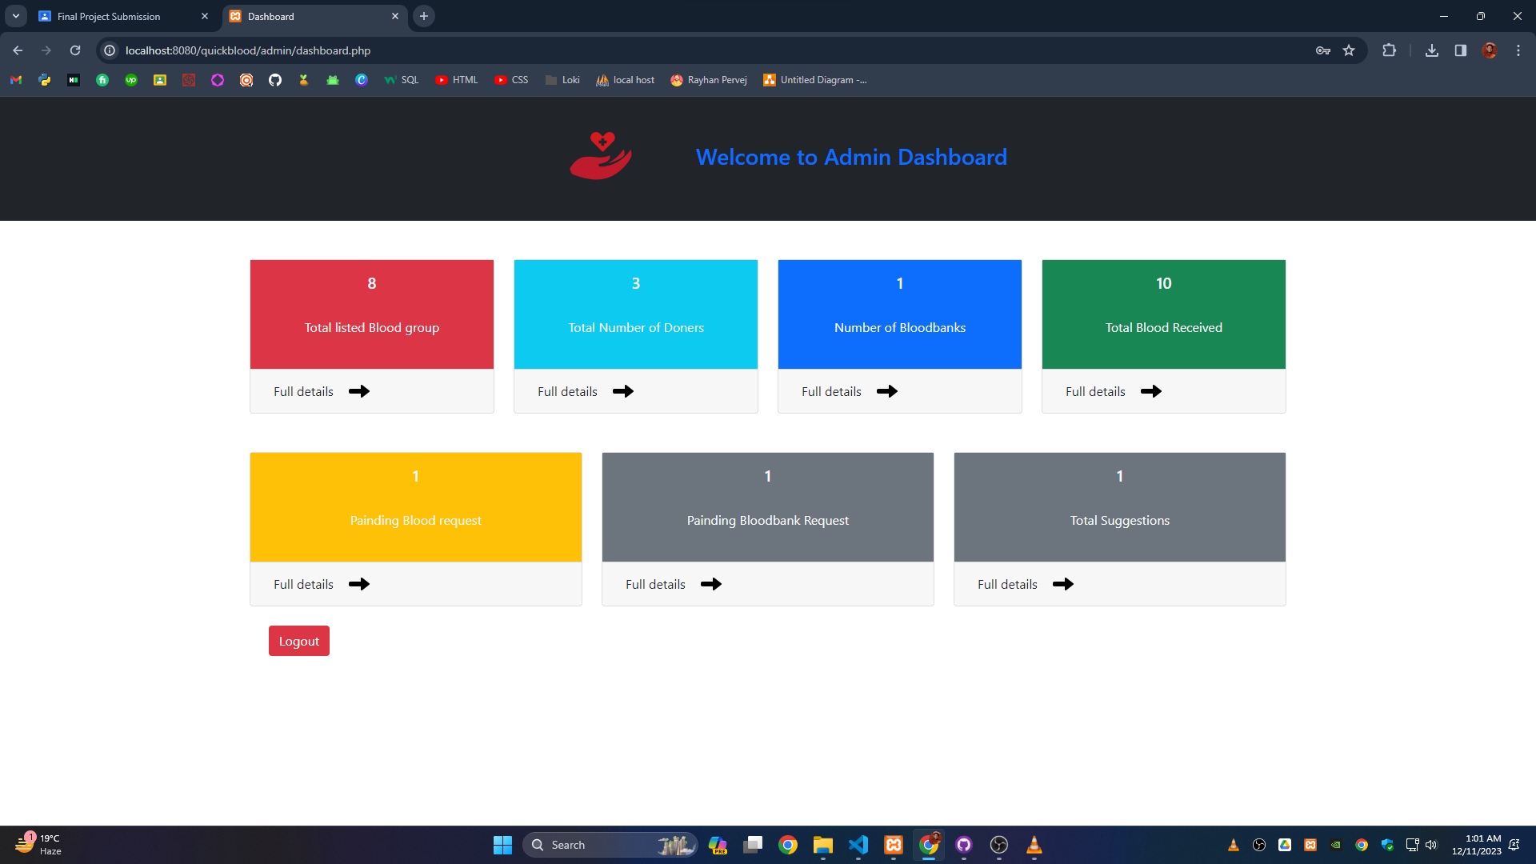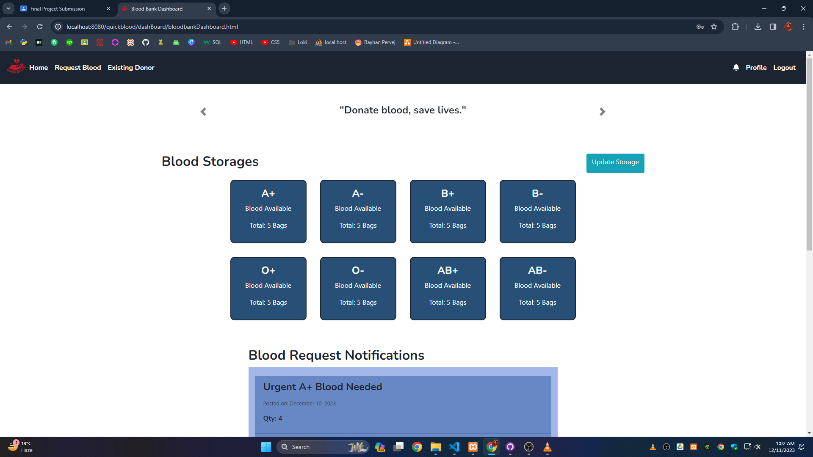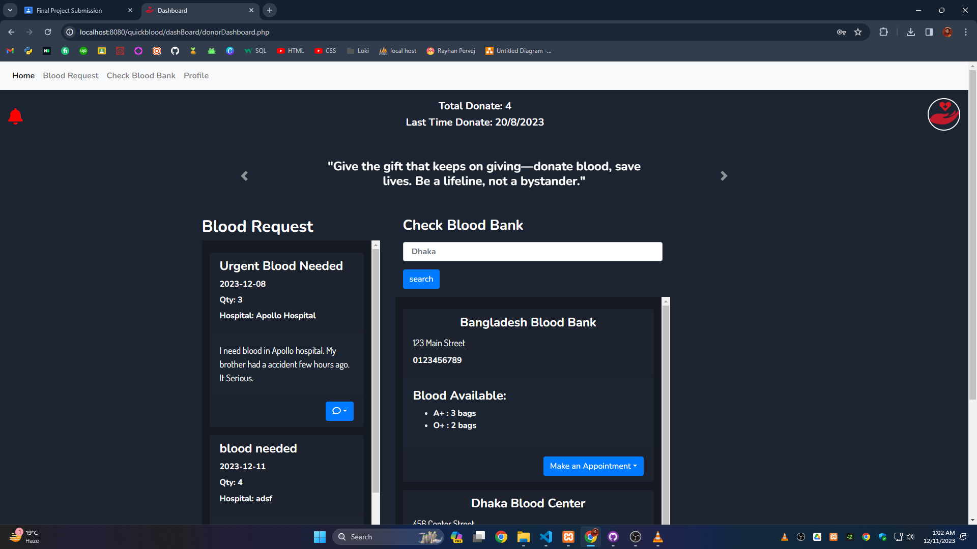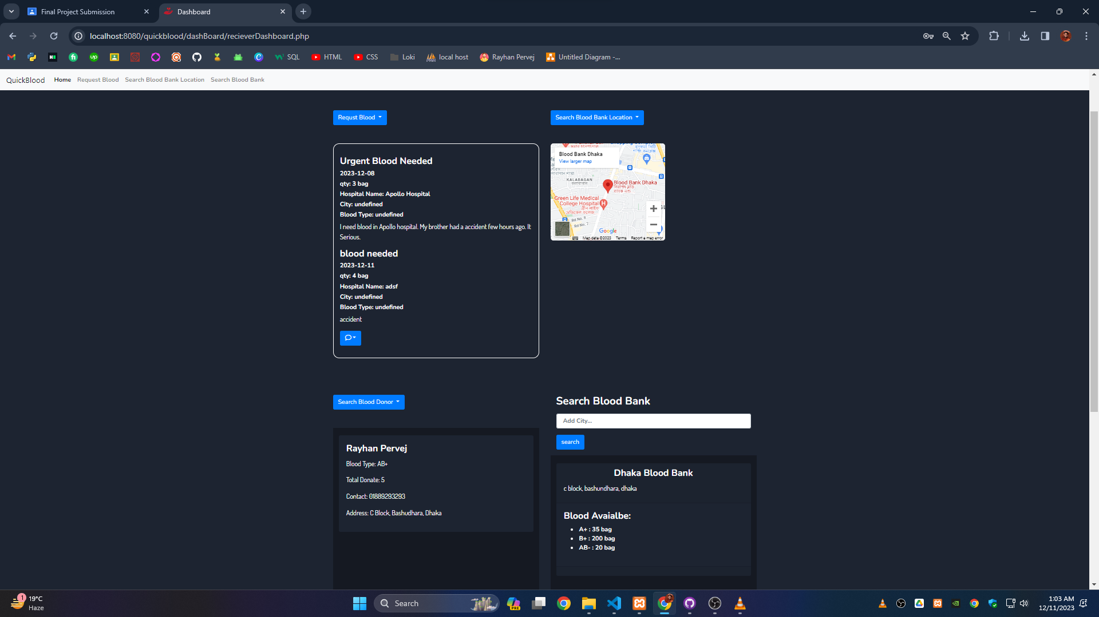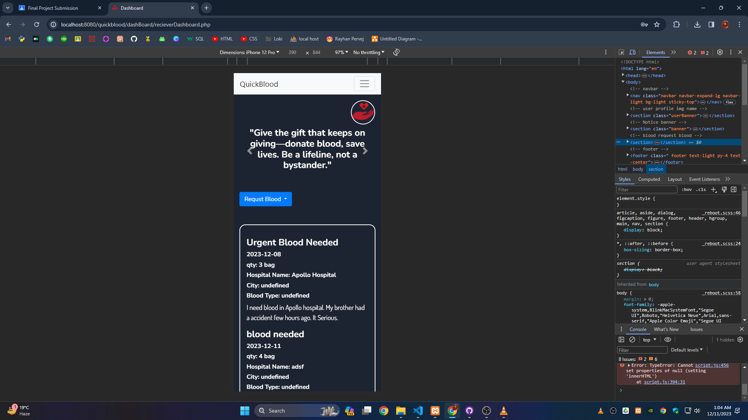

*Figure 2: QuickBlood Interface*

**Results and Discussion**

The results and outcomes of the Quick Blood website are as follows:

* **Software product:**

The Quick Blood website is a software product that showcases how to connect a blood donor, recipient, and blood banks. It shows an easy way to interact with blood donors and receive blood quickly in an emergency. Key features of Quick Blood website:

o Appointment scheduling

o Donation history tracking

o Notifications and Updates

o Integration with Blood Banks

o Customizable User Profiles

o Interactive Dashboard

o Feedback and Support

* **User interface:** The Quickblood website has an attractive, responsive, and user-friendly user interface. It has a polished and eye-catching appearance because of its consistent and logical design, which incorporates graphics, animations, typefaces, colors, and images. Optimal user experiences are guaranteed across various screen sizes and devices thanks to responsive and adaptive design. The Quick Blood website also has a user-friendly and intuitive design that uses menus, buttons, links, forms, and feedback to facilitate user interaction and navigation which gives it a professional look
* **Functionality:** The Quick Blood website has a functionality that is reliable, efficient, and secure. The Quick Blood website has reliable and efficient functionality that uses HTML, CSS, JavaScript, Bootstrap, PHP, and MySQL to implement the features and the logic of the Quick Blood website. Data and transactions are protected by authentication, validation, sanitization, and encryption.
* **Performance**: Fast, reliable, and scalable performance are Quick Blood's strong points. Techniques for caching, compression, minification, and optimization cut down on bandwidth usage and loading times. The Quick Blood website also has a satisfying usability that uses engaging and interactive content, attractive and appealing design, and positive and constructive feedback to create a pleasant user experience.
* **Compatibility:** The Quickblood website is cross-browser and cross-device compatible. Utilizing HTML5, CSS, and JavaScript standards and capabilities, the quickblood website boasts cross-browser compatibility, guaranteeing its functioning and appearance across a range of web browsers, including Chrome, Brave, Safari, and Edge. The quickblood website also features cross-device compatibility, which makes use of media queries, and bootstrap to guarantee the website's design and functioning across a range of platforms, including desktops, laptops, tablets, and smartphones.

The challenges, difficulties, issues, and risks encountered during the Quick Blood website are as follows:

* **Time constraints**: Strict deadlines require effective time management and work prioritization. The Quick Blood website had a tight deadline that required the software developer to complete the project within a limited time frame.
* **Design changes:** Design modifications necessitated successful stakeholder communication and change execution.
* **Technical issues:** The software developer had to troubleshoot and fix the code, database, and server of the Quick Blood website due to various technical concerns. The software developer had to find and fix the problems and bugs using debugging tools, testing tools, and problem-solving methodologies.
* **Security Risks:** To avoid illegal access, the software developer had to take security measures, access, modification, or deletion of the data and transactions on the Quick Blood website due to security issues. Because of this risk, the software developer had to secure the data and the transactions using techniques including encryption, validation, sanitization, and authentication.

The comparison and contrast of the Quick Blood website with the existing or alternative solutions are as follows:

* **Strengths:** The Quick Blood website has some strengths that make it stand out from the existing or alternative solutions, such as:

o **Unique Design:** The app has a distinctive, customized design that captures the compassion and urgency of blood donation.

o **User-Interactive Features:** With Quick Blood's dynamic and interactive interface, users can explore, filter, navigate, and participate in discussions regarding blood donation with ease.

o **Efficient Appointment Management:** Donors can efficiently schedule blood donation appointments through a user-friendly interface.

o **Notifications:** Donors receive timely reminders from the app regarding.

* **Weaknesses:**

1. Limited scope and audience.
2. Complex functionality requires more resources and skills.
3. A competitive market necessitates uniqueness and creativity.

* **Opportunities:**

1. **Expansion of scope**: Expanding beyond blood donation services is one way that Quick Blood may increase its effect. It might be possible to draw in a wider range of users by including elements about wellness advice, general health monitoring, or wider medical aid.
2. Improvement of functionality and performance through advanced web development technologies.
3. Expanded market reach by successful promotion and marketing tactics.

* **Threats:** The Quick Blood website has some threats that can reduce its value or impact, such as:

1. Competition and imitation: Other healthcare apps that are already available or are just getting started that offer similar or better features, functionality, and content could pose a threat to Quick Blood. Staying innovative and continuously improving services is crucial to counteract this threat.
2. Issues and risks from the web development environment and users. Reducing these threats requires putting strong security measures in place and adhering to rules.
3. Potential obsolescence due to rapid changes in web development technologies. Regular updates and adding new features can solve this threat.

**Conclusion and Recommendations**

The development of the Quick Blood website shows us the significant milestone in solving the challenges within the blood donation process. The Quick Blood website is designed for friendly use for all the users. Since the website is responsive and the strengths of this website is unique design, user-based features and efficient way to interact with all types of users. Though we have so many issues in the current version, which we will try to solve and make the website more friendly and easy to understand. Our stakeholders loved the first design and they also told us to improve in some places. We will work on that in the near future. While designing the website, we face some challenges and we have to redesign some of the sections. Since this website is for all 3 types of users. We have to make sure that All of the users can interact in real time. We used a relational database so that we can track the data of the users and improve the website and its systems. This website is valuable for new web developers, they can understand how to make a user based website. Gathering all the information we build a website for society where a person can get the blood fast and donate the blood to the right person.

Here are some recommendations for more constructive work, improvement and ideas that can be implemented in the near future.

1. **Expanding the field:** Quick Blood will stick with the blood donation system only. We will add more features like health checking, medical consultation, doctor appointment etc.
2. **Getting Better:** As the time goes we see similar things created, we can make sure that will make this website better and use the latest technology for keeping up with the people we want.
3. **Reaching People:** Since this is a social website for emergency use, we will use good strategies to tell about this website and the blood donation importance. So that they can get awareness and use this platform.
4. **Keep It Safe:** Make sure the website is safe and the data is protected. User privacy must be an important part of the safety. Regular Updates and adding new features will also help the website from becoming outdated.